**PIZZA SALES SQL QUERIES**

**I. KPI’s**

**1. Total Revenue:**

SELECT

SUM(total_price) AS total_revenue

FROM pizza_sales;

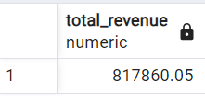

**2. Average Order Value**

SELECT

(SUM(total_price) / COUNT(DISTINCT order_id)) AS Avg_order_Value FROM pizza_sales

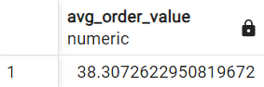

**3. Total Pizzas Sold**

SELECT

SUM(quantity) AS total_pizza_sold

FROM pizza_sales

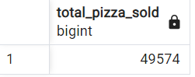

**4. Total Orders**

SELECT

COUNT(DISTINCT order_id) AS Total_Orders

FROM pizza_sales

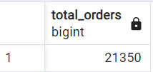

**5. Average Pizzas Per Order**

SELECT

CAST(CAST(SUM(quantity) AS DECIMAL(10,2)) /

CAST(COUNT(DISTINCT order_id) AS DECIMAL(10,2)) AS DECIMAL(10,2))

AS Avg_Pizzas_per_order

FROM pizza_sales

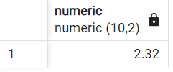

**II. Daily Trend for Total Orders**

SELECT

TO_CHAR(order_date, 'Day') AS order_day,

COUNT(DISTINCT order_id) AS total_orders

FROM

pizza_sales

GROUP BY

TO_CHAR(order_date, 'Day')

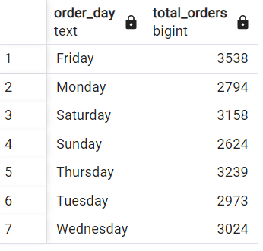

**III. Hourly Trend for Orders**

SELECT

EXTRACT(HOUR FROM order_time) AS order_hours,

COUNT(DISTINCT order_id) AS total_orders

FROM

pizza_sales

GROUP BY

EXTRACT(HOUR FROM order_time)

ORDER BY

order_hours;

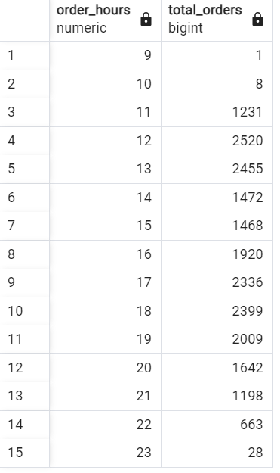

**IV. % of Sales by Pizza Category**

SELECT pizza_category, CAST(SUM(total_price) AS DECIMAL(10,2)) as total_revenue,

CAST(SUM(total_price) * 100 / (SELECT SUM(total_price) from pizza_sales) AS DECIMAL(10,2)) AS PCT

FROM pizza_sales

GROUP BY pizza_category

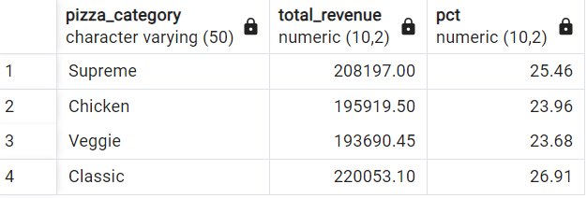

**V. % of Sales by Pizza Size**

SELECT pizza_size, CAST(SUM(total_price) AS DECIMAL(10,2)) as total_revenue,

CAST(SUM(total_price) * 100 / (SELECT SUM(total_price) from pizza_sales) AS DECIMAL(10,2)) AS PCT

FROM pizza_sales

GROUP BY pizza_size

ORDER BY pizza_size

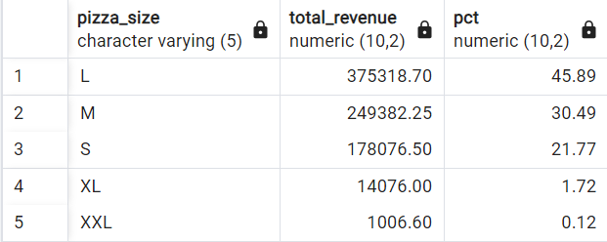

**VI. Total Pizzas Sold by Pizza Category**

SELECT

pizza_category,

SUM(quantity) AS total_quantity_sold

FROM pizza_sales

GROUP BY pizza_category

ORDER BY total_quantity_sold DESC;

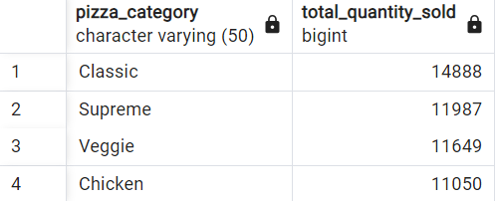

**VII. Top 5 Best Sellers by Total Pizzas Sold**

SELECT pizza_name, SUM(quantity) AS Total_Pizza_Sold

FROM pizza_sales

GROUP BY pizza_name

ORDER BY Total_Pizza_Sold DESC

LIMIT 5

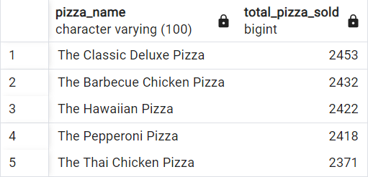

**VIII. Bottom 5 Best Sellers by Total Pizzas Sold**

SELECT pizza_name, SUM(quantity) AS Total_Pizza_Sold

FROM pizza_sales

GROUP BY pizza_name

ORDER BY Total_Pizza_Sold ASC

LIMIT 5

